Wellness Survey
Your Annual Wellness Visit
(Annual Physical)
is a great time to check on
your overall health.

I am currently enrolled in the Company High-Deductible Health Plan.
My last Annual Wellness Visit was (MON/YEAR): __________
My next Annual Wellness Visit will be (MON/YEAR): _________
I will not enroll in Medicare in the next 6 months.
I understand funds will appear in my HSA as soon as possible.
I understand the deadline to submit this form is 09/30.
My full name is: ______________________________
- Draft an email and attach this form
- Select “Request a Delivery Receipt” 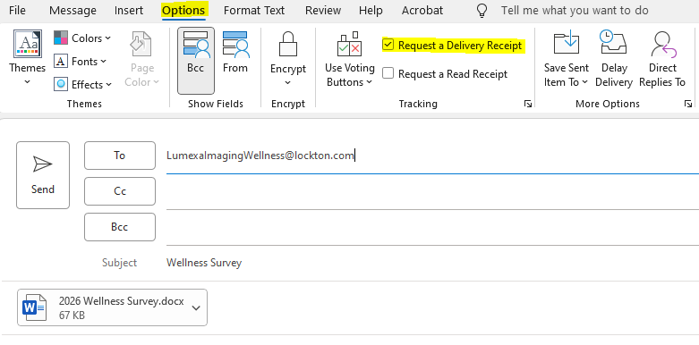
- Email to: LumexaImagingWellness@Lockton.com

